Set 7: Customer Demographics Analysis
Field | Details
Department | AIML
Course Code / Course Name | DSA0602 / Data Handling and Visualization
Experiment | Data Visualization using R
Name | B Mallika
Register Number | 192324234
Date | 03-10-2026
Day | Saturday

Aim
To visualize customer age and gender distributions, display customer demographic information in a table, and design an interactive dashboard for demographic exploration.
Dataset: Customer Demographics
Customer ID | Age | Gender | Income ($)
1 | 28 | Female | 50000
2 | 35 | Male | 60000
3 | 42 | Female | 75000

PROGRAM 1: Bar Chart of Customer Ages
Create a bar chart to visualize the distribution of customer ages. Label the axes and title the chart.
# Dataset
customer_id <- c(1, 2, 3)
age <- c(28, 35, 42)
# Bar Chart
barplot(age,
names.arg = customer_id,
xlab = "Customer ID",
ylab = "Age (Years)",
main = "Age Distribution of Customers",
col = "skyblue")
Output 1: Bar Chart of Customer Ages
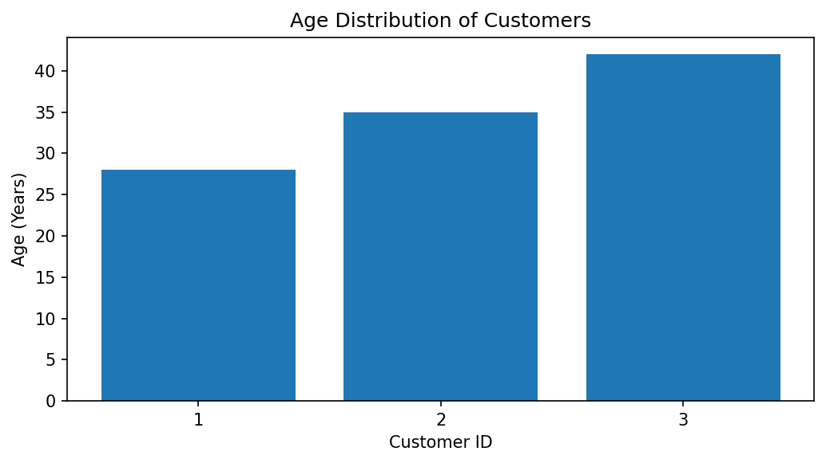
Observation: The chart displays the ages of the three customers. Customer 3 is the oldest at 42 years, while Customer 1 is the youngest at 28 years.

PROGRAM 2: Pie Chart of Customers by Gender
Generate a pie chart to represent the distribution of customers by gender.
# Dataset
gender <- c("Female", "Male", "Female")
# Calculate gender frequency
gender_count <- table(gender)
# Pie Chart
pie(gender_count,
labels = paste(names(gender_count), gender_count),
main = "Customer Distribution by Gender",
col = c("pink", "skyblue"))
Output 2: Pie Chart of Customers by Gender
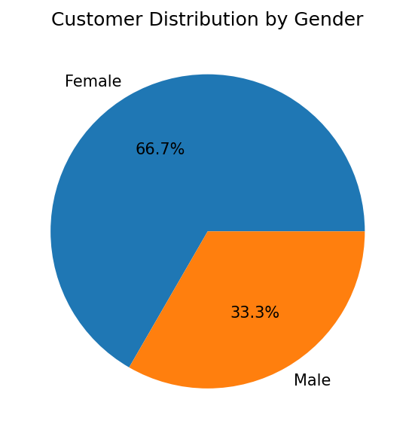
Observation: Two customers are Female and one customer is Male. Therefore, Female customers represent 66.7% and Male customers represent 33.3% of this sample.

PROGRAM 3: Table of Customer Demographic Information
Build a table to show the demographic information for each customer. Label the table elements.
# Create demographic dataset
customer_data <- data.frame(
Customer_ID = c(1, 2, 3),
Age = c(28, 35, 42),
Gender = c("Female", "Male", "Female"),
Income = c(50000, 60000, 75000)
)
# Display table
print(customer_data)
Output 3: Table of Customer Demographic Information
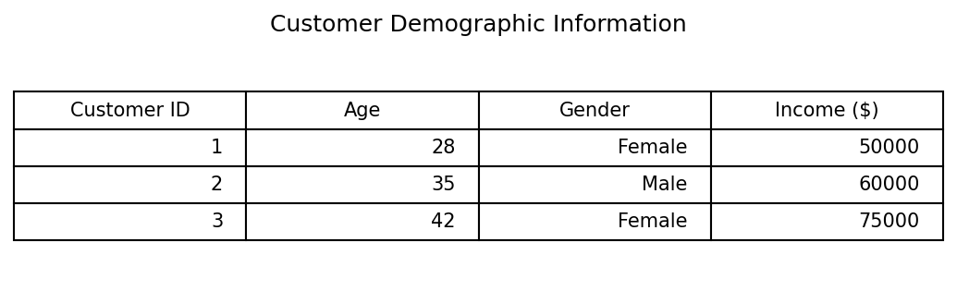
Observation: The table displays Customer ID, Age, Gender, and Income for all three customers.

PROGRAM 4: Interactive Customer Demographics Dashboard
Develop a Tableau dashboard combining the bar chart, pie chart, and the table for interactive exploration of customer demographics.
# Tableau dashboard steps
# 1. Connect to the Customer Demographics data.
# 2. Create a bar chart: Customer ID on Columns and Age on Rows.
# 3. Create a pie chart: Gender on Color and Number of Records on Angle.
# 4. Create a text table with Customer ID, Age, Gender, and Income.
# 5. Add all three worksheets to a new Dashboard.
# 6. Add Gender and Age filters and apply them to the required views.
# 7. Add dashboard actions so selecting a chart filters the other views.
# R code to prepare and inspect the same source data:
customer_data <- data.frame(
Customer_ID = c(1, 2, 3),
Age = c(28, 35, 42),
Gender = c("Female", "Male", "Female"),
Income = c(50000, 60000, 75000)
)
print(customer_data)
Output 4: Interactive Customer Demographics Dashboard
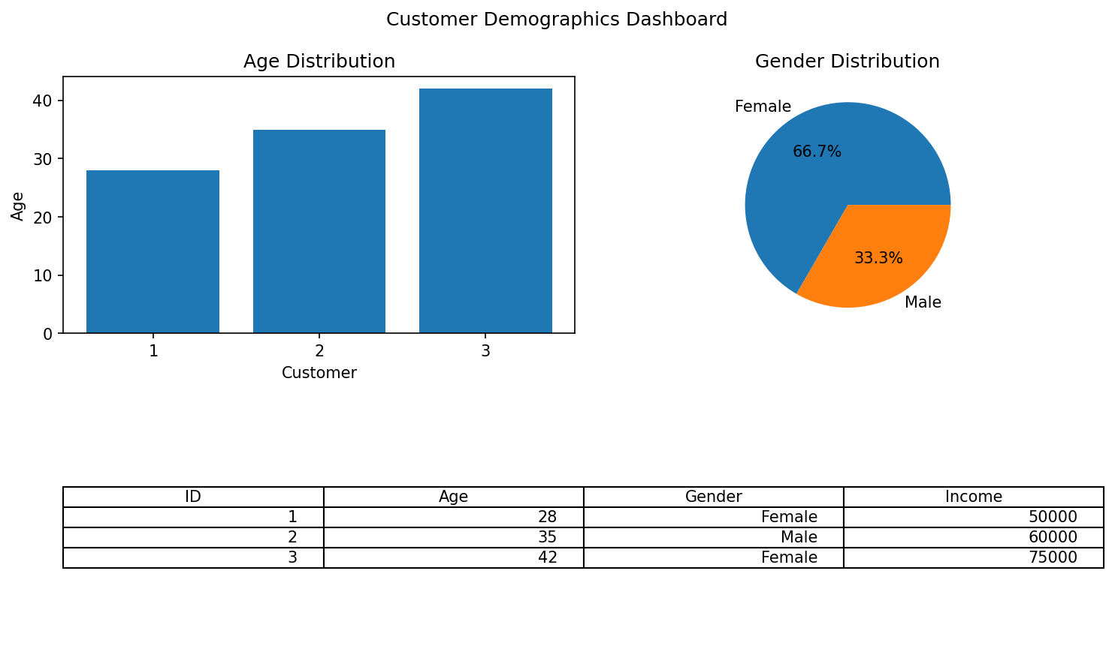
Observation: The Tableau dashboard combines the age bar chart, gender pie chart, and demographic table. Filters allow users to explore the available customer records.
Procedure
Create vectors for customer ID, age, gender, and income.
Use barplot() to visualize customer ages.
Use table() and pie() to display the gender distribution.
Create a data frame and print it to display demographic information.
In Tableau, create the three worksheets, combine them in a dashboard, and add interactive filters.
Result
The customer demographic data was visualized successfully using a bar chart and pie chart. A demographic table and an interactive Tableau dashboard layout were also prepared.
Key R Functions Used
Function | Purpose
barplot() | Creates a bar chart.
table() | Calculates category frequencies.
pie() | Creates a pie chart.
data.frame() | Combines variables into a data frame.
print() | Displays the data frame.

LAB EXPERIMENT RECORD

Set 8: Employee Performance Analysis
Department: AIML
Course Code / Course Name: DSA0601 / Data Handling and Visualization
Experiment: Data Visualization using R
Aim
To visualize employee performance scores, compare employee counts across departments, display employee performance details in a table, and design an interactive dashboard.
Dataset: Employee Performance
Employee ID | Department | Years of Service | Performance Score
1 | Sales | 5 | 85
2 | HR | 3 | 92
3 | Marketing | 7 | 78

PROGRAM 1: Line Chart of Employee Performance
Create a line chart to visualize the performance trend of employees over time. Label the axes and title the chart.
# Dataset
employee_id <- c(1, 2, 3)
years_service <- c(5, 3, 7)
performance <- c(85, 92, 78)
# Order employees by years of service
ord <- order(years_service)
# Line Chart
plot(years_service[ord], performance[ord],
type = "o",
xaxt = "n",
xlab = "Years of Service",
ylab = "Performance Score",
main = "Employee Performance by Years of Service",
col = "blue",
pch = 19)
axis(1, at = years_service[ord],
labels = employee_id[ord])
Output 1: Line Chart of Employee Performance
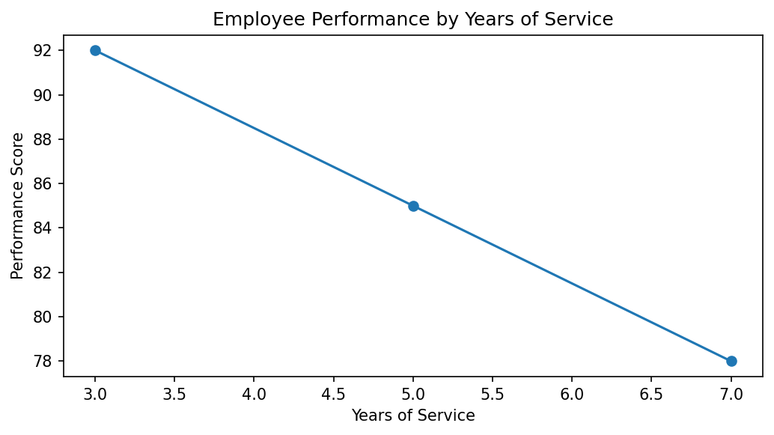
Observation: Employee 2 has the highest performance score (92) with 3 years of service. Employee 3 has the lowest score (78) with 7 years of service. The dataset is cross-sectional and does not contain repeated observations over time; therefore, the chart compares employees by years of service rather than showing a true time-series trend.

PROGRAM 2: Bar Chart of Employees by Department
Generate a bar chart showing the distribution of employees across different departments. Label the chart elements.
# Dataset
department <- c("Sales", "HR", "Marketing")
# Department frequency
dept_count <- table(department)
# Bar Chart
barplot(dept_count,
xlab = "Department",
ylab = "Number of Employees",
main = "Employee Distribution by Department",
col = "lightgreen")
Output 2: Bar Chart of Employees by Department
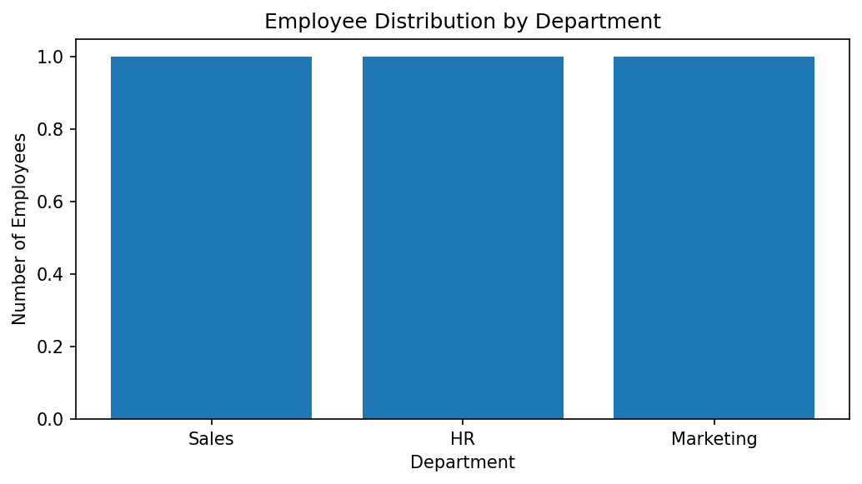
Observation: Sales, HR, and Marketing each have one employee. Hence, all three departments have equal representation in the given dataset.

PROGRAM 3: Table of Employee Performance
Build a table to display the performance data for each employee. Label the table elements.
# Create employee performance table
employee_data <- data.frame(
Employee_ID = c(1, 2, 3),
Department = c("Sales", "HR", "Marketing"),
Years_of_Service = c(5, 3, 7),
Performance_Score = c(85, 92, 78)
)
# Display table
print(employee_data)
Output 3: Table of Employee Performance
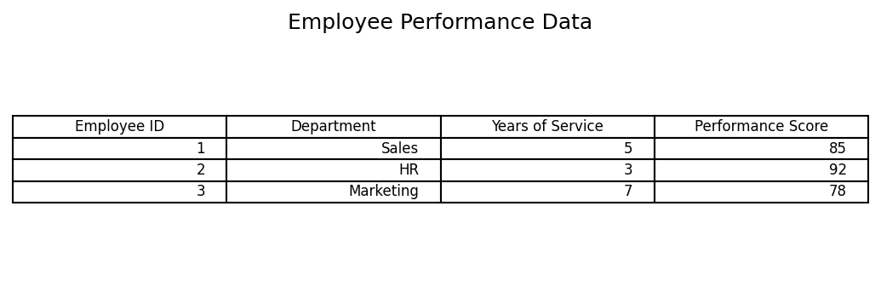
Observation: The table displays employee ID, department, years of service, and performance score for each employee.

PROGRAM 4: Interactive Employee Performance Dashboard
Develop a Tableau dashboard combining the line chart, bar chart, and the table for interactive exploration of employee performance data.
# Tableau dashboard steps
# 1. Connect to the Employee Performance dataset.
# 2. Create a line chart using Years of Service and Performance Score.
# 3. Create a bar chart using Department and COUNT(Employee ID).
# 4. Create a text table containing all employee performance fields.
# 5. Add the three worksheets to a new Dashboard.
# 6. Add Department and Years of Service filters.
# 7. Configure dashboard actions to filter related views.
# R data preparation
employee_data <- data.frame(
Employee_ID = c(1, 2, 3),
Department = c("Sales", "HR", "Marketing"),
Years_of_Service = c(5, 3, 7),
Performance_Score = c(85, 92, 78)
)
print(employee_data)
Output 4: Interactive Employee Performance Dashboard
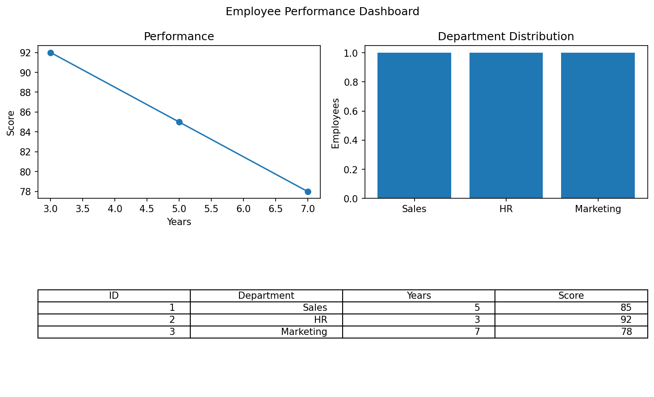
Observation: The dashboard combines employee performance, department distribution, and the employee table. Department and years-of-service filters support interactive exploration.
Procedure
Create vectors for employee ID, department, years of service, and performance score.
Use plot() to compare performance scores by years of service.
Use table() and barplot() to show the number of employees in each department.
Create and print a data frame containing all employee details.
In Tableau, combine the line chart, department bar chart, and table in a dashboard with filters.
Result
Employee performance was visualized using a line chart and department-wise bar chart. The employee data table and an interactive Tableau dashboard layout were also prepared.
Key R Functions Used
Function | Purpose
plot() | Creates a line chart.
order() | Orders observations by years of service.
table() | Calculates department frequencies.
barplot() | Creates a department bar chart.
data.frame() | Creates a structured employee table.

LAB EXPERIMENT RECORD

Set 9: Online Learning Activity Analysis
Department: AIML
Course Code / Course Name: DSA0601 / Data Handling and Visualization
Experiment: Data Visualization using R
Aim
To analyze online learning activity using a histogram, boxplot, bubble scatter plot, monthly average quiz-score line chart with moving average smoothing, and an interactive Tableau dashboard.
Dataset: Online_Learning_Activity.csv
Student_ID | Gender | Age | Course | Study_Time (hrs) | Videos_Watched | Quiz_Score | Login_Date
L01 | Male | 20 | R | 3.5 | 12 | 78 | 2025-01-05
L02 | Female | 22 | R | 4.2 | 15 | 85 | 2025-01-05
L03 | Male | 19 | SQL | 2.0 | 8 | 65 | 2025-02-08
L04 | Female | 21 | R | 5.0 | 18 | 92 | 2025-02-08
L05 | Male | 23 | R | 2.5 | 9 | 70 | 2025-03-12
L06 | Female | 20 | SQL | 4.0 | 14 | 88 | 2025-03-12

PROGRAM 1: Histogram and Boxplot of Quiz Scores
Import the dataset in R. Plot a histogram for Quiz_Score. Draw a boxplot of Quiz_Score by Course. Add title and labels. Interpret student performance.
# Create dataset
learning <- data.frame(
Student_ID = c("L01","L02","L03","L04","L05","L06"),
Gender = c("Male","Female","Male","Female","Male","Female"),
Age = c(20,22,19,21,23,20),
Course = c("R","R","SQL","R","R","SQL"),
Study_Time = c(3.5,4.2,2.0,5.0,2.5,4.0),
Videos_Watched = c(12,15,8,18,9,14),
Quiz_Score = c(78,85,65,92,70,88),
Login_Date = c("2025-01-05","2025-01-05","2025-02-08",
"2025-02-08","2025-03-12","2025-03-12")
)
# Histogram
hist(learning$Quiz_Score,
main = "Distribution of Quiz Scores",
xlab = "Quiz Score",
ylab = "Frequency",
col = "skyblue")
# Boxplot by Course
boxplot(Quiz_Score ~ Course,
data = learning,
main = "Quiz Scores by Course",
xlab = "Course",
ylab = "Quiz Score",
col = c("lightgreen", "orange"))
Output 1: Histogram and Boxplot of Quiz Scores
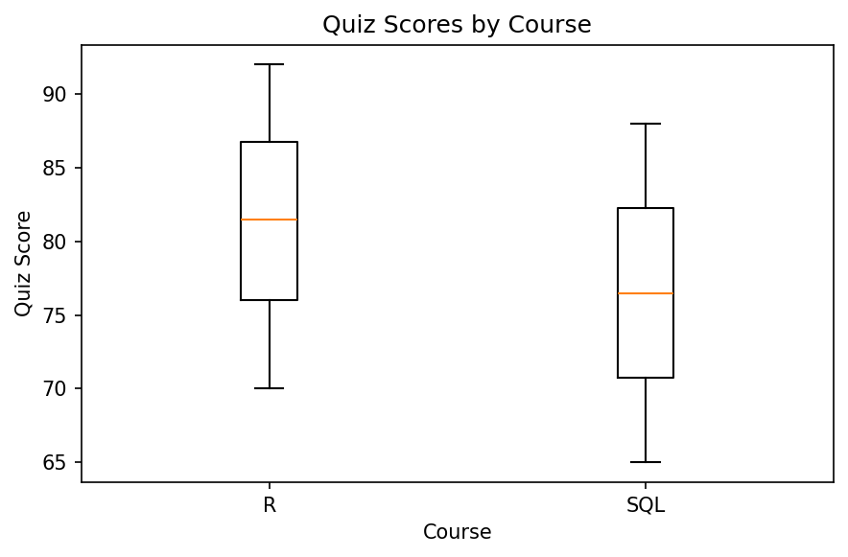
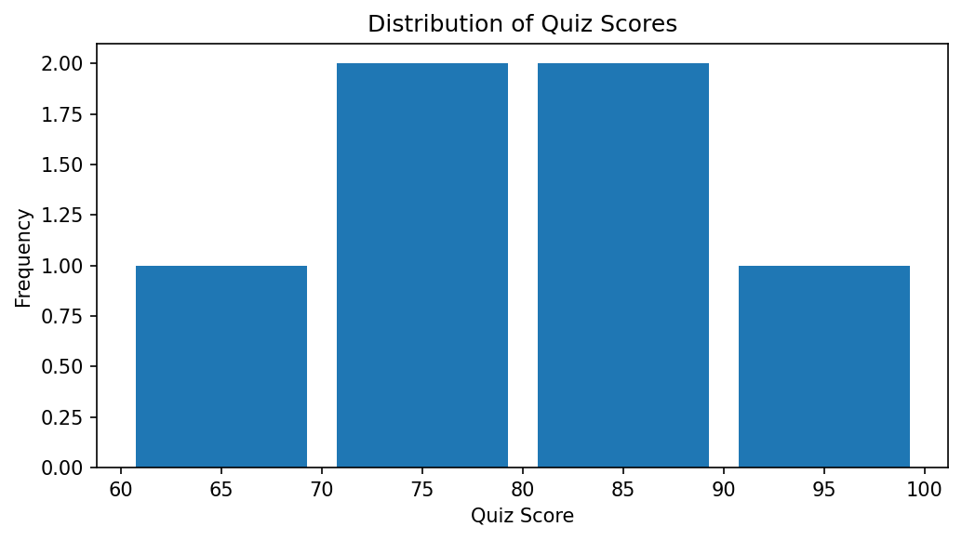
Observation: Quiz scores range from 65 to 92. R course scores are 70, 78, 85, and 92, while SQL scores are 65 and 88. The histogram shows the distribution of all six scores, and the boxplot compares scores between the two courses.

PROGRAM 2: Bubble Scatter Plot of Study Time and Quiz Score
Create a scatter plot using R programming between Study_Time and Quiz_Score. Represent Videos_Watched using bubble size. Apply transparency. Explain the learning pattern.
# Use the learning dataset created in Program 1
# Scale bubble sizes using Videos_Watched
bubble_size <- 1 + learning$Videos_Watched / 8
# Bubble Scatter Plot
plot(learning$Study_Time, learning$Quiz_Score,
pch = 21,
cex = bubble_size,
bg = adjustcolor("steelblue", alpha.f = 0.45),
col = "navy",
xlab = "Study Time (Hours)",
ylab = "Quiz Score",
main = "Study Time vs Quiz Score")
# Add student labels
text(learning$Study_Time, learning$Quiz_Score,
labels = learning$Student_ID,
pos = 3,
cex = 0.7)
Output 2: Bubble Scatter Plot of Study Time and Quiz Score
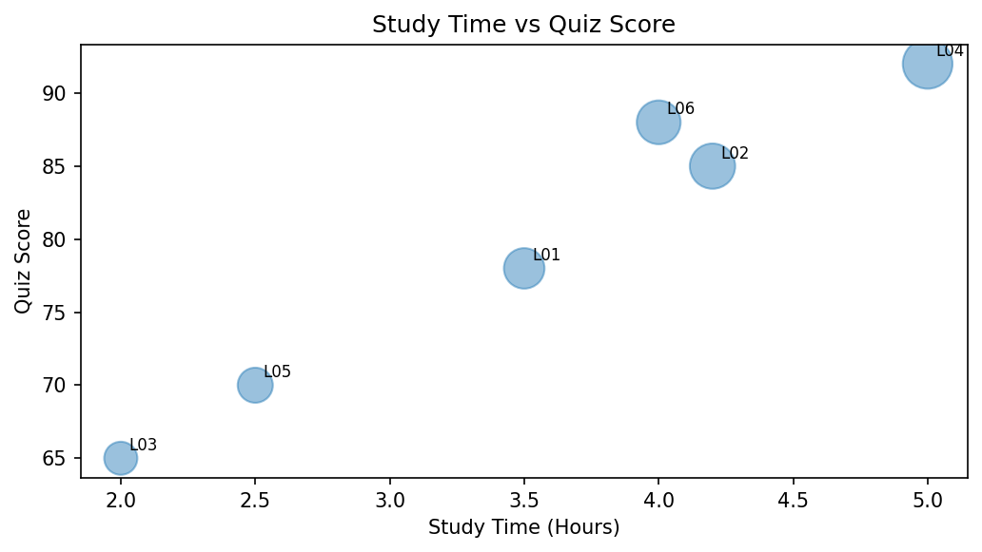
Observation: The plotted data generally suggests that students with more study time tend to obtain higher quiz scores, although the pattern is not perfectly consistent. Larger bubbles represent students who watched more videos. The sample contains only six students, so the pattern should be interpreted cautiously.

PROGRAM 3: Monthly Average Quiz Score with Moving Average
Using R programming, convert Login_Date into Date format. Calculate average quiz score per month. Plot a line chart. Apply moving average smoothing. Identify the trend.
# Convert Login_Date into Date format
learning$Login_Date <- as.Date(learning$Login_Date)
# Extract month
learning$Month <- format(learning$Login_Date, "%Y-%m")
# Calculate monthly average quiz score
monthly_avg <- aggregate(Quiz_Score ~ Month,
data = learning,
FUN = mean)
# Ensure chronological order
monthly_avg <- monthly_avg[order(monthly_avg$Month), ]
# Calculate 2-month trailing moving average
monthly_avg$Moving_Average <- as.numeric(
stats::filter(monthly_avg$Quiz_Score,
filter = c(1/2, 1/2),
sides = 1)
)
# Line chart
plot(seq_len(nrow(monthly_avg)), monthly_avg$Quiz_Score,
type = "o",
xaxt = "n",
xlab = "Month",
ylab = "Average Quiz Score",
main = "Monthly Average Quiz Score",
col = "blue",
ylim = range(c(monthly_avg$Quiz_Score,
monthly_avg$Moving_Average),
na.rm = TRUE))
axis(1, at = seq_len(nrow(monthly_avg)),
labels = monthly_avg$Month)
# Add moving average line
lines(seq_len(nrow(monthly_avg)),
monthly_avg$Moving_Average,
type = "o",
col = "red",
lty = 2)
legend("topright",
legend = c("Monthly Average", "2-Month Moving Average"),
col = c("blue", "red"),
lty = c(1, 2),
pch = 1)
# Display monthly results
print(monthly_avg)
Output 3: Monthly Average Quiz Score with Moving Average
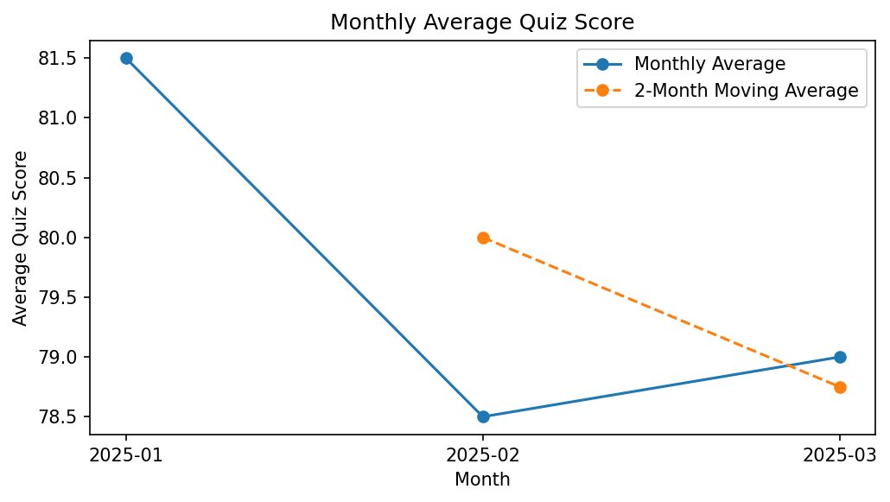
Observation: Monthly average quiz scores are January 81.5, February 78.5, and March 79.0. The scores decrease from January to February and increase slightly in March. The two-month trailing moving average smooths the short-term variation; its first value is unavailable because two months are needed.

PROGRAM 4: Interactive Online Learning Dashboard
Import Online_Learning_Activity.csv into Tableau. Create a bar chart showing average quiz score by Course. Create a scatter plot (Study Time vs Quiz Score). Add filter for Gender and Course. Design a mini interactive dashboard.
# Tableau dashboard steps
# 1. Save the learning data as Online_Learning_Activity.csv.
# 2. Open Tableau and connect to the CSV file.
# 3. Create a bar chart:
# Course -> Columns; Quiz_Score -> Rows; change aggregation to AVG.
# 4. Create a scatter plot:
# Study_Time (hrs) -> Columns; Quiz_Score -> Rows.
# Student_ID -> Detail; Videos_Watched -> Size.
# 5. Add Gender and Course as filters.
# 6. Show the filters and apply them to both worksheets.
# 7. Create a new Dashboard and place both worksheets on it.
# 8. Add a dashboard title and configure filter actions.
# Optional R code to export the dataset for Tableau:
write.csv(learning,
"Online_Learning_Activity.csv",
row.names = FALSE)
Output 4: Interactive Online Learning Dashboard
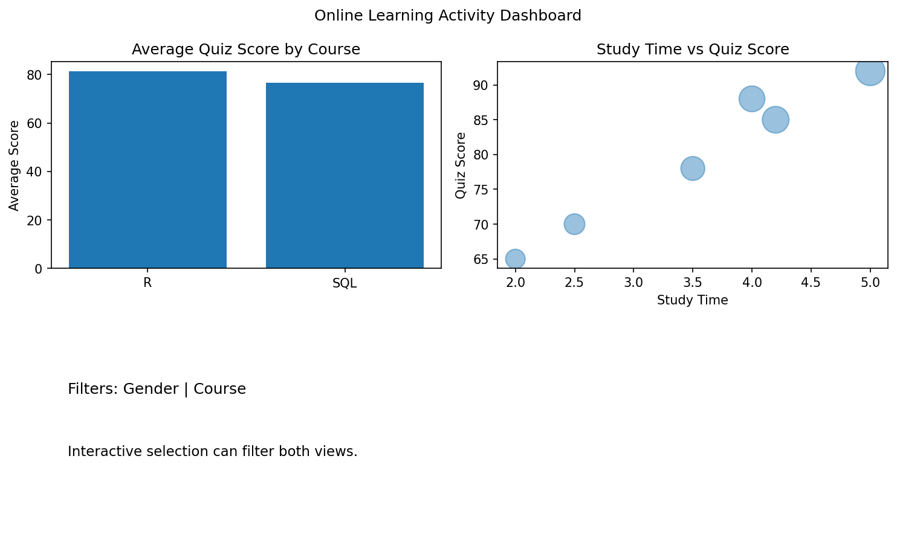
Observation: The Tableau mini dashboard contains average quiz score by course and a study-time versus quiz-score scatter plot. Gender and Course filters allow users to explore the learning activity data.
Procedure
Import or create the Online_Learning_Activity dataset in R.
Use hist() to plot the quiz-score distribution and boxplot() to compare scores by course.
Use plot() with bubble size based on Videos_Watched and transparency to visualize study time versus quiz score.
Convert Login_Date using as.Date(), calculate monthly averages using aggregate(), and apply a moving average using stats::filter().
Import the CSV into Tableau, create the average-score bar chart and scatter plot, add Gender and Course filters, and combine the views in a dashboard.
Result
The online learning activity data was analyzed using a histogram, course-wise boxplot, bubble scatter plot, and monthly average quiz-score line chart with moving average smoothing. A Tableau dashboard design with course and gender filters was also prepared.
Key R Functions Used
Function | Purpose
hist() | Creates a histogram.
boxplot() | Compares quiz-score distributions by course.
plot() | Creates scatter and line charts.
adjustcolor() | Applies transparency to bubble colors.
as.Date() | Converts date strings into Date format.
aggregate() | Calculates monthly average quiz scores.
stats::filter() | Calculates moving average smoothing.
write.csv() | Exports data to a CSV file.

